# ==============多表查询==============









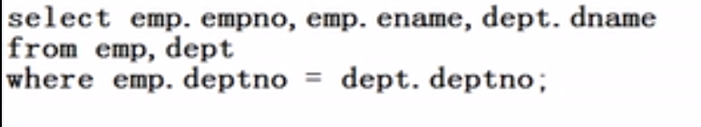

**select emp.empno,emp.ename,dept.dname from emp,dept where emp.deptno=dept.deptno**;





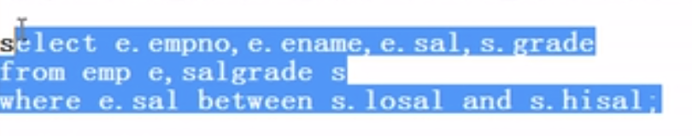

**select e.empno,e.ename,e.sal,s.grade from emp e,salgrade s where e.sal between s.losal and s.hisal;**

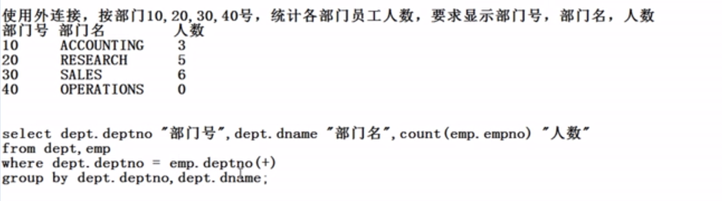

**select dept.deptno "部门号",dept.dname "部门名",count(emp.empno) "人数" from dept,emp where dept.deptno=emp.deptno(+)**

**group by dept.deptno,dept.dname; 左外连接：Oracle特有**

**select dept.deptno "部门号",dept.dname "部门名",count(emp.empno) "人数" from dept,emp where emp.deptno(+)=dept.deptno**

**group by dept.deptno,dept.dname; 右外连接：非Oracle特有**

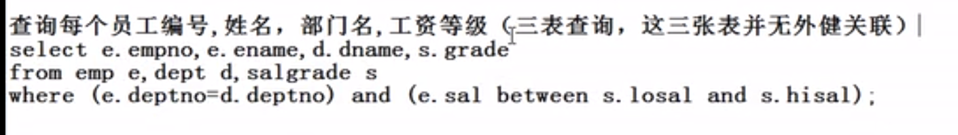

SELECT E.EMPNO,E.ENAME,D.DNAME,S.GRADE FROM EMP E,DEPT D,SALGRADE S WHERE (E.DEPTNO=D.DEPTNO) AND (E.SAL BETWEEN S.LOSAL AND S.HISAL);





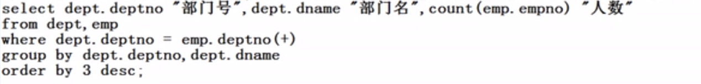

**select dept.deptno "部门号",dept.dname "部门名",count(emp.empno) "人数" from dept,emp where dept.deptno=emp.deptno(+) group by dept.deptno,dept.dname order by 3 desc;**

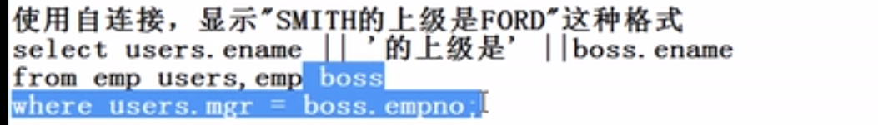

**select users.ename ||'的上级是'|| boss.ename from emp users ,emp boss where users.mgr=boss.empno; 这里不能用user，可能会和已知的关键字冲突**

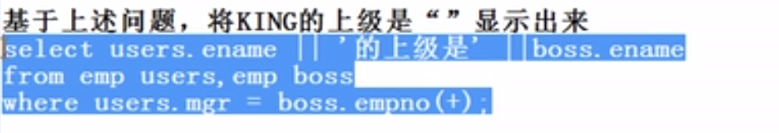

**select users.ename ||'的上级是'|| boss.ename from emp users ,emp boss where users.mgr=boss.empno(+);**

**注意内连接与外连接的区别：**

